7-2: Project Two README

Tyler Shurilla
Southern New Hampshire University
CS 340: Client/Server Development
Professor Sanford
April 18, 2026

Grazioso Salvare Dashboard Project
Project Overview
This project implements a full-stack dashboard application designed for Grazioso Salvare to identify dogs suitable for search and rescue training. The application connects a MongoDB database to a Python-based dashboard built using the Dash framework.
The dashboard allows users to filter animal records based on specific rescue categories and view the results dynamically through an interactive data table, a geolocation map, and a supporting chart. The goal is to provide a clean and intuitive interface that reduces the time required to locate qualified animals.
Dashboard Features
The dashboard includes the following functionality:
- Interactive filtering options for:
  - Water Rescue
  - Mountain or Wilderness Rescue
  - Disaster or Individual Tracking
  - Reset (returns full dataset)
- A dynamic data table that updates based on selected filters
- A pie chart showing breed distribution of filtered results
- A geolocation map that updates based on selected table row
- Integrated branding including the Grazioso Salvare logo and developer identifier
Screenshots of functionality:
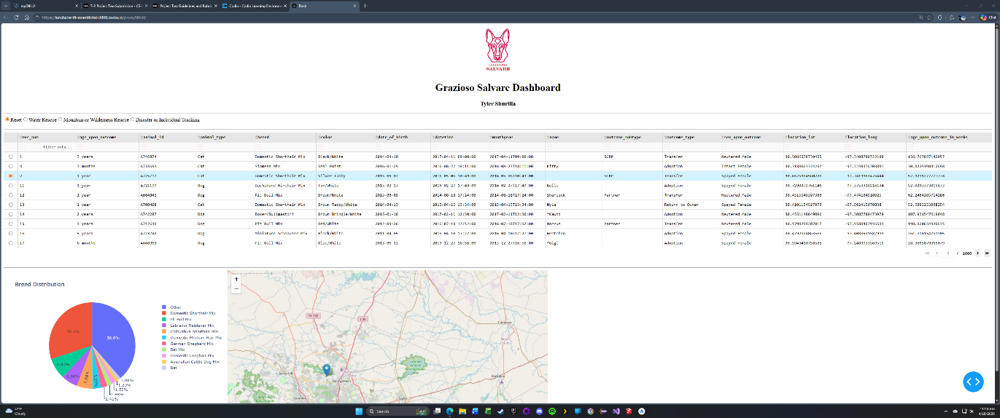
Figure 1: Initial Dashboard State (Reset)
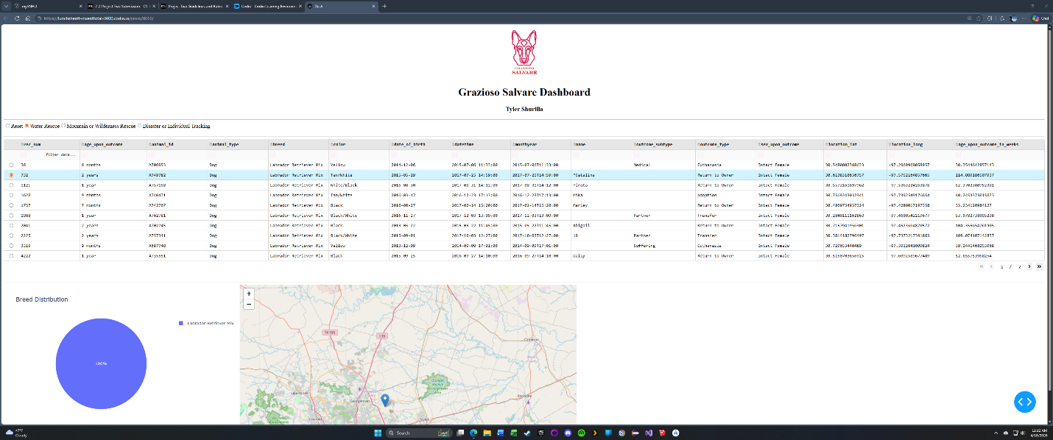
Figure 2: Water Rescue Filter Applied

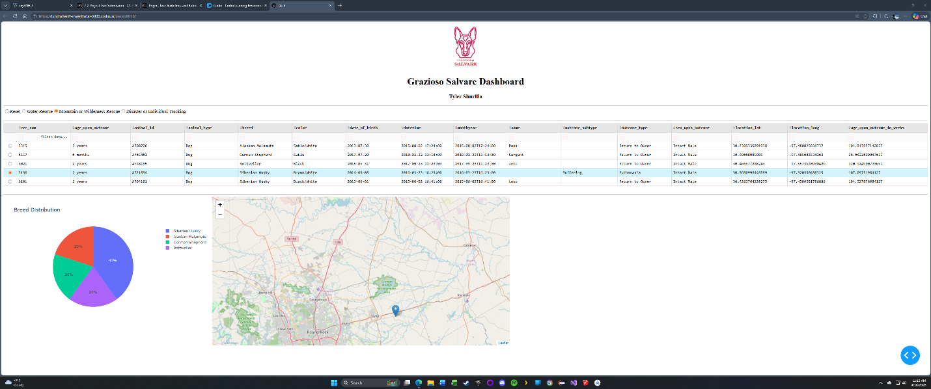
Figure 3: Mountain or Wilderness Rescue Filter Applied
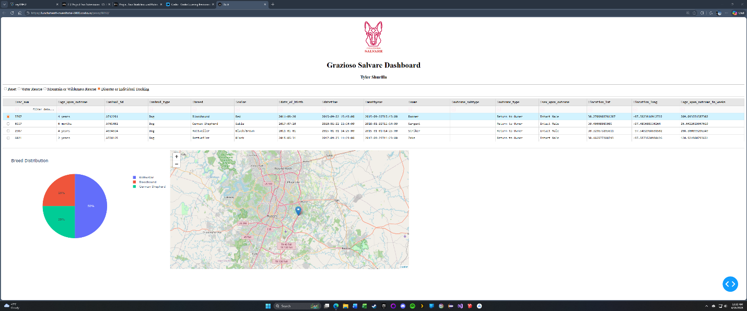
Figure 4: Disaster or Individual Tracking Filter Applied
Each screenshot demonstrates that the table, chart, and map update correctly based on the selected filter.

Tools and Technologies Used
- Python – Core programming language used for application logic
- MongoDB – Database used to store and query animal shelter data
- PyMongo – Python library used to interact with MongoDB
- Pandas – Used for transforming query results into structured data for display
- Dash (Plotly) – Framework used to build the interactive dashboard interface and handle callbacks between components
- Dash DataTable – Provides filtering, sorting, and pagination features
- Dash Leaflet – Used to render the geolocation map
- Plotly Express – Used to generate the pie chart visualization

Rationale for Design Choices
MongoDB was selected as the database because it stores data in a flexible document format, which aligns well with the structure of the animal shelter dataset. It also integrates cleanly with Python through PyMongo, allowing queries to be executed directly from the dashboard.
The Dash framework was used to build the front-end because it allows Python to control both the application logic and the user interface. This made it possible to implement filtering, callbacks, and visualizations without requiring separate front-end technologies.
The CRUD Python module was reused from Project One to maintain separation between the database layer and the dashboard logic. This follows a basic MVC pattern, where:
- MongoDB serves as the model
- Dash components act as the view
- Callback functions act as the controller

Steps to Reproduce the Project
- Open the Codio environment and launch the terminal.
- Import the dataset into MongoDB using the following command:
  - mongoimport --db aac --collection animals --type csv --file aac_shelter_outcomes.csv --headerline
- Start the MongoDB shell:
  - mongosh
- Create the required database user:
  - use aac
  - db.createUser({
  - user: "aacuser",
  - pwd: "aacpass",
  - roles: [{ role: "readWrite", db: "aac" }]
  - })
- Exit the Mongo shell and return to JupyterLab.
- Open the file ProjectTwoDashboard.ipynb.
- Run all cells using “Run All”.
- Click the generated link to launch the dashboard in the browser.
- Use the filter options to verify that the table, chart, and map update correctly.

Challenges Encountered and Solutions
One challenge was managing the interaction between the data table and the visual components. The map and chart both depend on the current state of the filtered dataset, so ensuring that all components updated correctly required careful use of Dash callbacks.
Another issue was handling the MongoDB ObjectId field, which caused errors when rendering the data table. This was resolved by removing the _id column before passing the data into the dashboard.
The pie chart initially became difficult to read when displaying the full dataset due to the number of unique breeds. This was improved by limiting the chart to the top results and grouping the remaining values into an “Other” category.

Contact
Tyler Shurilla

